SEPTEMBER IN THE VEGGIE GARDEN
AT BOOYONG

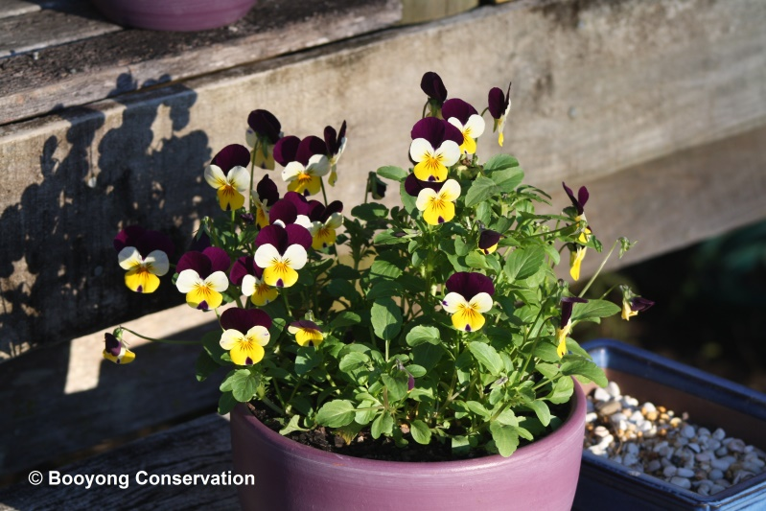
WHAT’S HAPPENING
New growth is appearing on the fruit trees and we are welcoming Spring at Booyong! We have recently planted new fruit trees in the Orchard, including pink and yellow Dragon Fruit and Pepino and Goji berries. In addition Chocolate Pudding fruit and additional fig and Mandarin trees have been planted. These trees are young and will take time to establish but it makes us so happy to know they’re in the ground.
The Herb garden has been replenished and includes parsley, oregano, thyme and chives. Edible flowers have also been replanted on the deck and are great additions to desserts and spring salads. Mint is going well in the pot and always a handy herb to have available.
At Booyong we are learning about permaculture and turning the Orchard into a Food Forest. We are also beginning to explore the concept of companion planting which is exciting and worthy of interest. We are very excited about the principles and ethics and will keep you abreast to our learning and changes as they occur.
We are looking forward to seeing the Bell peppers emerge, our lovely neighbour gifted them to us and we are looking forward to seeing how they go.
PREPARATION
In preparation for our food forest we are researching how to create a portable A-frame for new chickens to work up the ground and prepare it for planting green manure crops to improve the soil.
SEWING SEEDS
- Sew in pots or directly in ground depending on species and protect from frost or winds if necessary.
- Sow lettuce, tomatoes, eggplants, sweet peppers, chillies, cucumbers, celery, fennel, peas, corn and sweet potatoes, broad beans, red cabbages, spinach, kale, onions, leeks, carrots, turnips, peas, radishes, lettuce and asparagus seeds.
- At Booyong this year we are planting some carrots and spinach for the bunnies. They also love Nasturtiums so we’ll pop these in too! Until the food forest is established we will need to keep them protected from the kangaroos so we’ll see how they go.

MAINTANENCE
- The fruit trees have recently been fertilized and the frame has been built for the grapes.
- Rosella seeds have also been removed for replanting in October/November.
- Go through all seeds and organise for planting and storage with the help of our kitten Lysandra.

