DECEMBER IN THE
GARDEN
AT BOOYONG

WHAT’S HAPPENING
It’s been a very dry Winter at Booyong and this has been reflected in the state of the Vegetable garden and Orchard.
The Herb garden soil is in great shape and when I refreshed it with herbs recently I noticed several happy and healthy worms. This is perhaps due to the kitchen compost we added to the garden before planting
The bell peppers that we were gifted by our lovely neighbour Anne have been recently planted in the other half of the old water tank in the Orchard. When we last visited we noticed they were not doing too well. Something has been eating them and the soil is very dry despite lots of watering. This month, we’ve added a bike wheel and some netting and will begin to work on the soil soon.
The Persimmons are a plenty and the tree has been netted with black netting. Sadly two native birds were caught in there and died so we will use white netting in the future. We are very much looking forward to tasting our first persimmons next month.
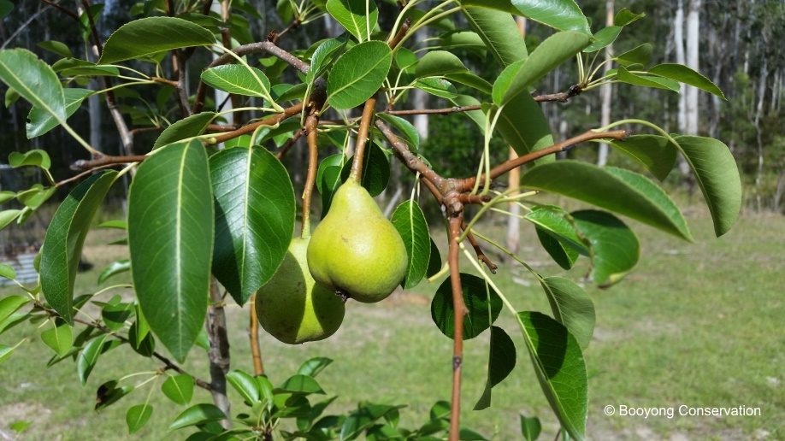
We’ve had our first pomegranate flowers appear, as well as two pears which were very exciting and the pepino berry bush is growing well. Our Pecan trees are covered in lovely lush leaves and there are some Macadamia nuts on the nut trees.
Sadly, the grapes have been eaten and whilst we have placed two posts to create something for them to grow on we are yet to wire and protect this plant. Perhaps we’ll be better prepared next year.
SEWING SEEDS
- Sow pumpkins, zucchinis and winter squash, fennel, chicory and any remaining Summer seeds you have.
- Sow asparagus seeds
PLANT
- Plant out cucumber, sweetcorn, melon and tomato seedlings
- Plant any herbs you have grown from seed
ROUTINE CARE
- Water regularly and keep weeds at bay
- Thin our new seedlings if they are overcrowded
- Spread mulch around plants to help retain moisture
- Tie up supports for runner beans
- Feed asparagus but don’t cut down till autumn
- Net cabbages and other brassicas to protect from caterpillars and birds
HARVESTING
- Peas and Broad beans
- New potatoes, onions, carrots and turnips, as well as beetroots
- Continue harvesting Rhubarb and artichokes as well as salad
- Lift all garlic and lay the bulbs out to dry

