MARCH IN THE
GARDEN
AT BOOYONG

WHAT’S HAPPENING
With the recent rains Booyong is becoming green and lush, the mornings are misty and the weather is cooling into the mornings and afternoons.
A blood orange, naval orange, lemonade tree and kaffir lime have been planted in the food forest, just in time before the weather cools.
The rhubarb and turmeric are going well in the planter boxes, as are the rosellas. We plan to harvest these and make rosella syrup when we visit next.
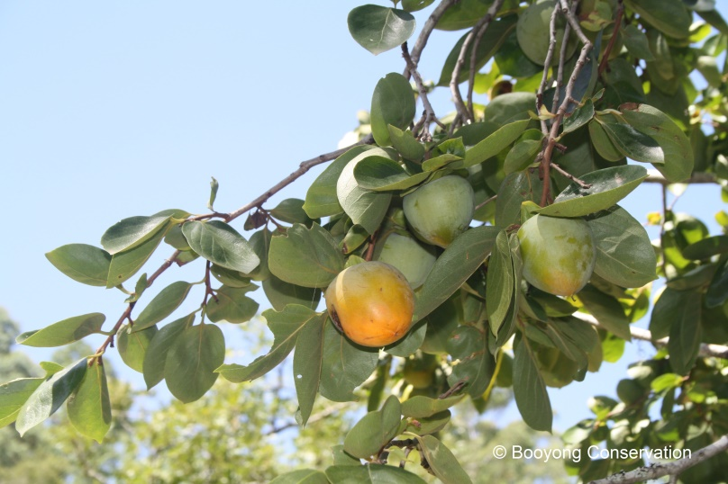
PREPARATION
- As our poultry increase in numbers, we are looking at creating a veggie garden bed located close by to grow food to feed them.
- We are also trialling wheat grass trays to feed the bunnies and chickens etc
SEWING SEEDS
- Sow Spinach, beetroot and Oriental salad seeds
PLANT
- Plant out cabbage, broccoli, cauliflower and spinach seeds for winter harvest
- The Lemongrass is established in the garden and we have propagated some lavender from home (Sydney) we intend to plant when we visit next.
ROUTINE CARE
- Remove any dead foliage and clean out veggie beds
- As the crops finish prepare the beds for winter seedlings
HARVESTING
- Persimmons are ready for harvest
- Harvest beans, zucchini, spinach, summer cabbage, eggplants, chillies and cucumbers etc
- Lift carrots and potatoes and beetroots

