APRIL IN THE FOOD FOREST
AT BOOYONG
WHAT’S HAPPENING
Things are beginning to slow down in the garden at Booyong as the weather cools and we are busy cutting firewood and preparing for winter.
PREPARATION
- Sow green manure for over wintering
- Dig in green manure sown in late summer
SEWING SEEDS
- Sow pea, cauliflower and cabbage seeds
PLANT
- Plant our garlic
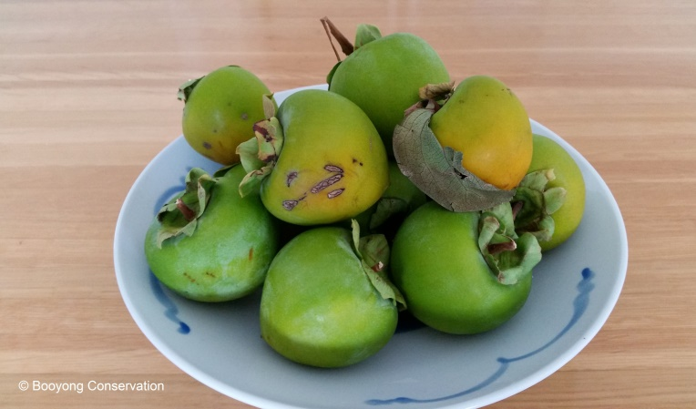
- Divide rhubarb crowns and plant new sets
ROUTINE CARE
- Clean up any plants that have finished cropping
- Take down canes and supports
- Prune Yellow foliage on asparagus back to the ground and mulch crowns with cow manure
HARVESTING
- Harvest tomatoes, cucumbers, corn, beans, eggplants, peppers, chillies and sweet potatoes
- Continue to pick zucchinis and summer squashes
- Continue picking spinach, leeks and lettuces
- Harvest mature pumpkins and melons
- The last of the persimmons are being harvested
OTHER TASKS
- Pull out old beans, zucchini and tomato plants

