MAY IN THE FOOD FOREST
AT BOOYONG

WHAT’S HAPPENING
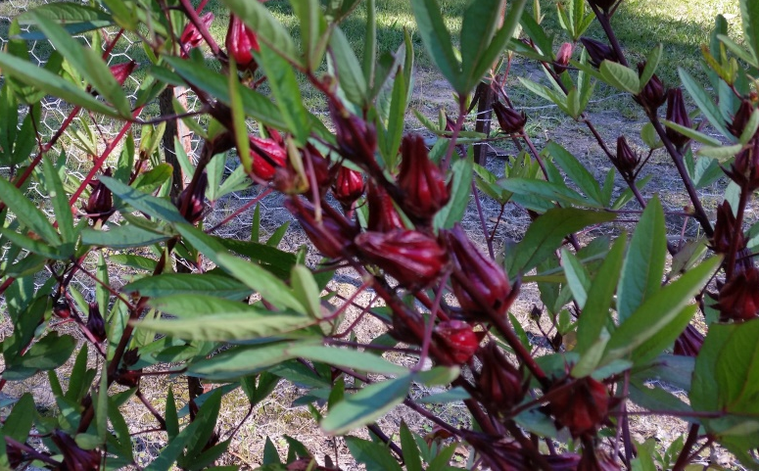
The rosella’s are ready for harvest and I have been busy making hibiscus Syrup. The oranges and grapefruits are growing bigger and starting to ripen which is fantastic. It’s been a very late start to winter followed by a long and dry summer. The persimmon tree is beginning to lose its leaves as the weather cools. We had a great crop this year.
The rhubarb is growing well and the turmeric near the cabin is starting to die off. In addition we may move it into a sunnier spot.
The dragon fruit is growing beautifully and we have planted some dwarf apples, jaboticaba and coffee trees in the food forest too, along with a blood and naval orange tree, lemonade, kaffir lime and blueberry plant.
The herb garden is coming along nicely and the lemongrass has settled in well to the garden bed near the palm tree.
PREPARATION
- Start digging well-rotted compost or manure into vegetable beds
SEWING SEEDS
- Sow beans (broad beans, fava beans) and peas (snow and sugar)
- Sow garden chives
- Sow cauliflower and carrot seed
- Sow lettuce and mustard greens
- Sow parsley and radish seeds
- Sow shallots, spinach and leeks
- Plant out strawberry plants

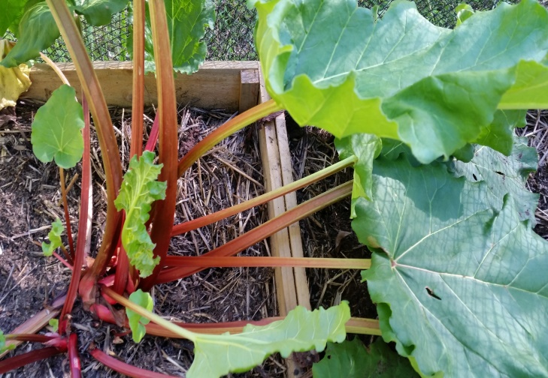
PLANT
- Divide rhubarb and plant out garlic.
ROUTINE CARE
- Continue to clear away plants that have finished cropping
HARVESTING
- Pick winter cabbages, cauliflowers, brussel sprouts, kale or Leeks
- Continue picking spinach and beans
- Limes are ready for harvest
- Anne’s bell peppers are turning a lovely red and are also ready to harvest
PROPOGATION
- Collect seeds from Anne’s Red Bell Peppers
OTHER TASKS
- Start collecting potash from fire for garden in Spring

