JUNE IN THE FOOD FOREST
AT BOOYONG

WHAT’S HAPPENING
It’s been a quiet time in the Food forest as the weather has cooled down. The lawns require less mowing and the boys have been busy chopping wood and doing maintenance on the machinery.
We have not been as prepared as we would like and have been chopping wood as required. We had hoped to have the fire wood shed full built, full and ready to go but were distracted by Farmgate. What a wonderful weekend that was – well worth the effort! The recent purchase of a log splitter will ensure we are more prepared next year and we have been blessed by a longer season of warm weather.
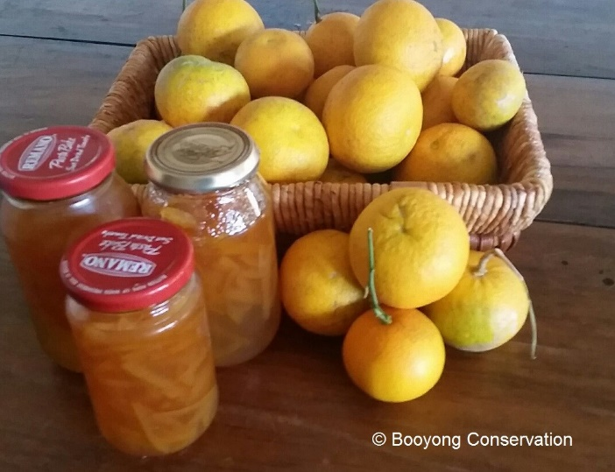
I have been busy making grapefruit marmalade which was fun and becoming a regular Winter occurrence.
We have also recently acquired a new bare root apricot and red currant plant for the food forest and are in the process of planning a resurrection of the Food forest dam. After speaking to a local permaculture enthusiast, we have decided to plant some water edibles around the dam which is very exciting.
A vegetable patch has also been created in the bunny hutch and we will purchase two more desexed and vaccinated bunnies soon. This will ensure there is constant feed and Bob won’t have to keep buying fruit and veg at the IGA.
PREPARATION
- Spread well-rotted manure or compost over vegetable garden beds
- Buy seed potatoes
- Order some seeds and go through seed inventory
- Seeds have been collected from the Rosella plants for next year
SEWING SEEDS
- Beans broad and fava to Harvest from September
- Sew Cabbage seeds to Harvest from July
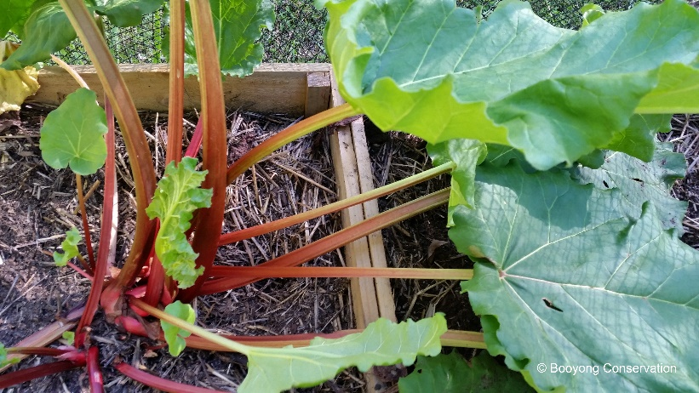
- Plant Garlic cloves to Harvest from October
- Kale to Harvest from July
- Continue to plant lettuce seeds and mustard greens
- Plant radish and pea seeds
- Plant out strawberry seedlings to harvest from September
- Plant beetroot seeds and spinach
PLANT
- Plant onion and shallot sets if ground isn’t too wet
- Planted Galangal as gifted from Lynn at Farmgate
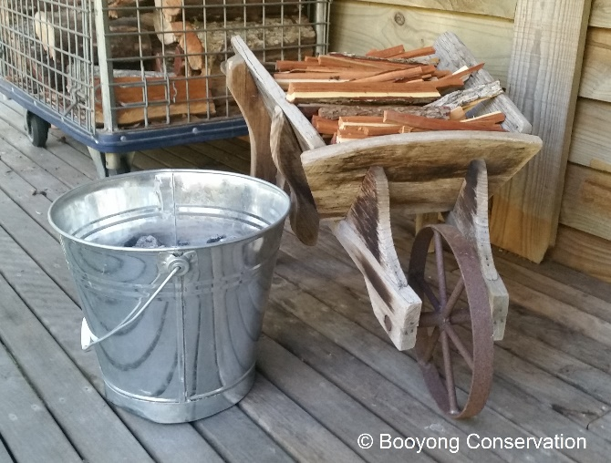
ROUTINE CARE
- The Rhubarb at our home in Sydney has successfully been separated, Booyong’s plants are just newly established so will be separated next year and the patch will be extended.
- The herb and chilli garden bed has been mulched
- Weed fireweed from the long grass in dam walls
- Add Blood and bone to strawberries
- Continue to collect potash from the fire for the Food forest gardens
HARVESTING
- Harvest Lemons
- Grapefruits harvested
- If you have them, pick winter Cabbages, Cauliflowers, Brussel sprouts, Kale and Leeks
- Dig up Turmeric

