AUGUST IN THE FOOD FOREST AT BOOYONG

WHAT’S HAPPENING
We’re in drought in NSW currently and this is reflected in the dryness of the property. Fortunately, the water tanks are reasonably full for the moment and the plants in the garden and orchard are all doing well.
The kangaroos are all looking for food and have demolished the tropical plants in the shower area, so we’ve taken them home to Sydney for some tender loving care. Bob is in the process of building structured garden beds around the shower and we will replant them soon and ensure they are protected with wire.
We’ve started planting green manure in the Food forest in an attempt to improve the soil.
PREPARATION
- Spread well-rotted manure or compost over vegetable garden beds
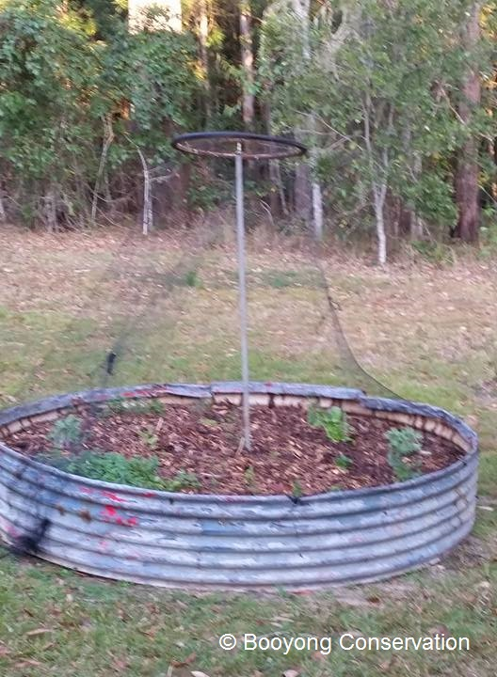
- Michelle purchased a portable seed case, so I can transport my seeds from Sydney to Booyong each time I visit and share with Bob
- Order required seeds and go through inventory
SEWING SEEDS
- Sow onion seeds
- Plant Legumes - Red Clover August - October for nitrogen under pecan trees
- Plant Artichokes (Globe), Asparagus, Beetroot, Cape Gooseberry, Capsicum, Bell Peppers, Chilli’s, Eggplant, Kohlrabi, Leeks, Lettuce, Mint, Mustard Greens, Peas, Parsnip, Potato, Radish, Rocket, Strawberries, Thyme, Tomato
- Seeds from the Mexican Coriander were collected

PLANT
- Plant onion and shallot sets if ground isn’t too wet
- 10m2 of Red clover was planted in the food forest to improve the soil
- Red chilli seeds planted in Chilli garden bed in food forest

ROUTINE CARE
- Top dressed herbs and herb garden mulched and weeded (the oregano is going crazy and may need to be placed in a pot)
- The netting on the Herb garden was replaced
- Fireweed was collected to prevent going to seed
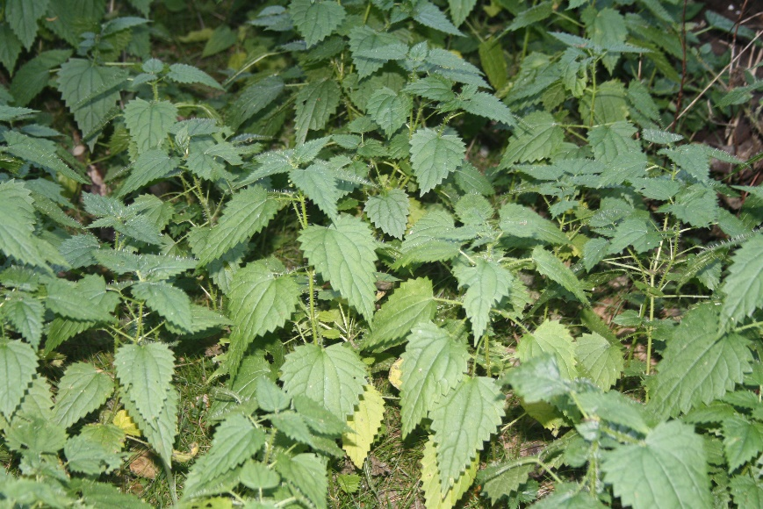
- Brett and Michelle weeded the lantana along the back fence of the conservation area
- Wisteria cut back and tied with string
HARVESTING
- Lemons – ready to harvest
- Pick winter Cabbages, Cauliflowers, Brussel sprouts, Kale and Leeks
NATIVE FOOD FOREST - HARVESTING
- Stinging Nestle Harvested - pesto made
NATIVE SEED PROPOGATION
- N/A
FARM MAINTANENCE
- Brett cleaned out shed gutters to keep water clean and a strong flow should we get rain
- Motorbike Serviced
- Blades on tractor sharpened
NATIVE GARDEN
- All going well, the lavender cuttings have settled in nicely

