JULY IN THE FOOD FOREST AT BOOYONG

WHAT’S HAPPENING
We’ve experienced extremely cold weather overnight and awoken to Jack frost Fortunately not too much has been affected, the paw paw trees and mangoes leaves have been frozen and everything else is fortunately ok.
The peach tree is blossoming in preparation for Spring which is so pretty.
Moved Chickens into Food Forest to break down grass.
PREPARATION
- Spread well-rotted manure or compost over vegetable garden beds
- Buy seed potatoes
- Order some seeds and go through seed inventory
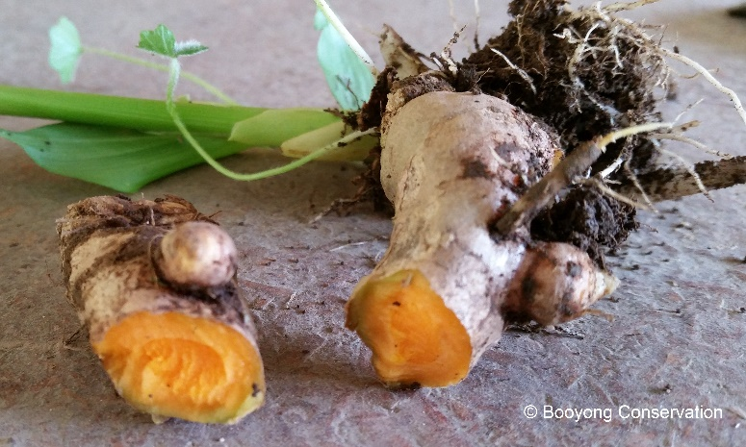
SEWING SEEDS
- Sow onion seeds
PLANT
- Plant onion and shallot sets if ground isn’t too wet
- Violets, celery, nasturtiums and radishes planted in Bunny garden bed
- Planted Red Currants
- Planted Apricot Bare rooted Tree
ROUTINE CARE
- Force Rhubarb if new shoots are beginning to sprout
- Fruit trees fertilized
- Native plants fertilized
HARVESTING
- Lemons – ready to harvest
- Pick winter Cabbages, Cauliflowers, Brussel sprouts, Kale and Leeks
- Grapefruits have been harvested by our recent guests
- Turmeric was harvested and replanted in Food forest
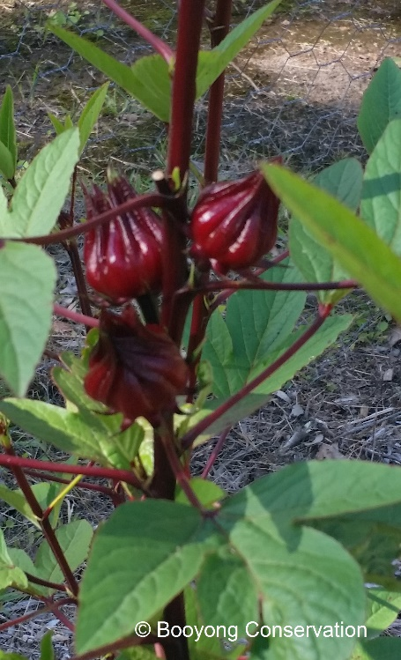
NATIVE FOOD FOREST
- Planted Davidson Plum
- Planted Tasmanni a lansalata
- Planted Billardiera scandens
- Native Violets – gifted by Mette
- Planted Austromyrtus copper tops Midyum Berry
NATIVE SEED PROPOGATION
- Rosella seeds collected for next year
FARM MAINTANENCE
- Fuel tank cleaned in tractor
- New wiring harness in tractor and gages replaced
- Shed Gutters cleaned
NATIVE GARDEN
- Planted Grevillea Lemon Supreme 1.5m
- Grevillea Glassadenia v venusta 2.5m
- Planted Native Violets – Gifted by Mette
- Planted lavender – grafted from home
- Planted Brachychlton discolour 30m
- Planted Birthday candles 1.5m
- Planted Pilotus Exaltus
- Planted Banksia Giant candles 4.5m

