JANUARY
AT BOOYONG

WHAT’S HAPPENING
Unlike 2018 when we had some rain, it’s been quite dry this summer so far. There are some clouds about but not much is happening. Despite this the orchard, appears to be doing ok.
We have some bell peppers growing in the old water tank in the orchard, but the soil is still dry and needs attention.
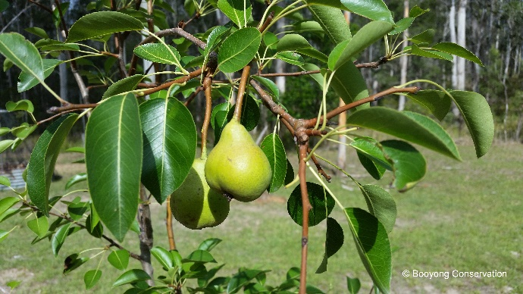
We have five pears growing on the pear tree which is exciting, and the citrus trees are all bearing fruit which is great. They are tiny, but they are there. The fig trees are growing slowly, and all the other trees look ok. They will need a great deal of water over the coming months if they are going to survive. Thank god for the water pod and the dam at the front of the property which just keeps on giving. Bob worked tirelessly throughout the hot summer month to keep the water up for the plants, we are so grateful!
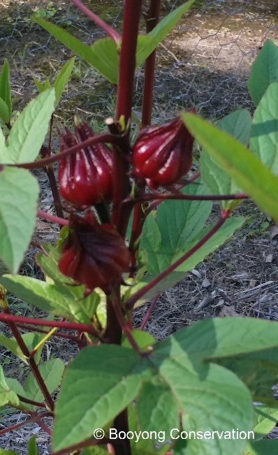
The turmeric which was moved into the food forest is starting to shoot which is fantastic. We are looking forward to a bumper harvest this year and I can’t wait to try out the new dehydrator.
A friend at Parramatta council has connected us with someone who had some Rosella seedlings, and these were planted in December around the Dam which has recently been cleaned out and they are doing well. They will be harvested and used to flavour her kombucha. I hope to do better at growing my own seeds this year!
A couple of pumpkins were also planted in December at the base of the dam and appear to be doing well.
Our persimmons tree is still lush and green and covered in fruit, we will be better prepared this year and hope to harvest lots. The two plants at the back of the garden bed are also bearing fruit, for a long period of time we were uncertain what they were!
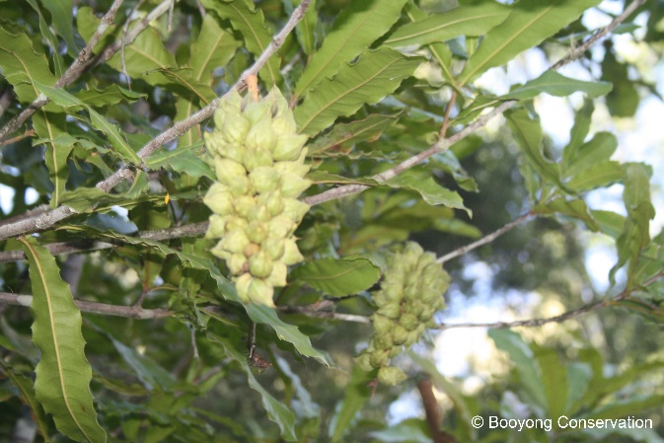
Sadly, our pecan nut trees, despite having a healthy number of flowers are once again not bearing nuts this year. It was a very dry winter and there has been little rain so we are thinking that may be a contributing factor.
The two macadamia nut trees in the orchard are bearing a great deal of nuts and they appear to be two different varieties of trees, One has bunches of nuts and the other are more singular.
SEWING SEEDS
- Make sowings of successional crops like lettuce, radishes, beans and spinach
PLANT OUT
- Plant out any remaining seedlings
ROUTINE CARE
- Water regularly and keep weeds at bay
- Pinch outside shoots of tomatoes
- Water pecan trees (1300 litres per day)
- Spread mulch around plants to help retain moisture
- Take out any crops or herbs that have bolted
- Prune Tropical Peach Fruit Tree
- Fertilise Paw Paw tree with Sea weed every 6-8 weeks before flowering, they also like potash and a sprinkle of gypsum. Don’t overwater to avoid root rot.
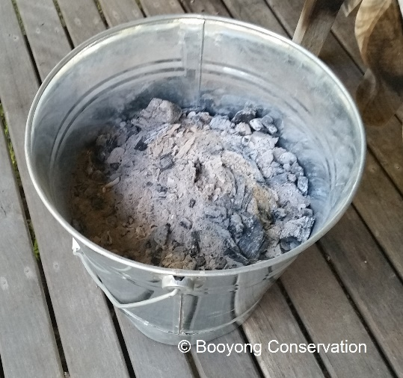
- Fertilise Macadamia nut tree - When fertilising use a native or citrus plant product as they are sensitive to phosphorus
HARVESTING
- Lettuce and spinach
- Eggplant, chillies, cucumbers and capsicums
- Continue harvesting beans, carrots, beetroot, celery, peas, beans and zucchini.
- Lift potatoes, onions and shallots
OTHER TASKS IN THE GARDEN
- Take cuttings of herbs to propagate
NORMAL FARM AND CABIN MAINTANENCE
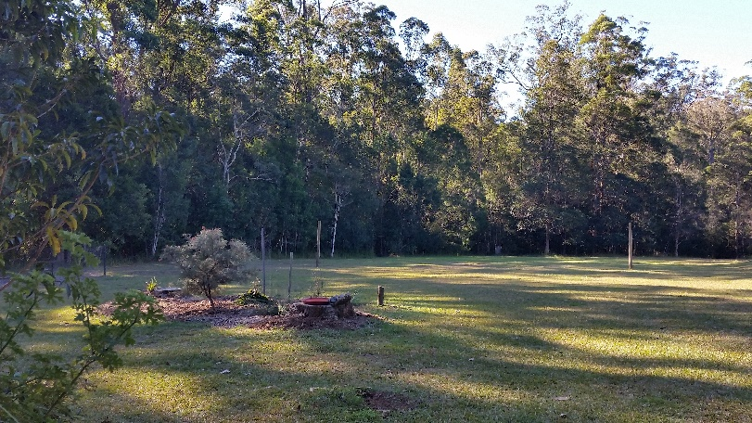
- The cabin garden beds have been weeded along with the car port area
- Brett has slashed the meadow
- The herb garden has been refreshed
- Shell has brushed down the external cabin walls
- Shell has once again weeded around the fruit trees

GARDEN BEDS AROUND CABIN
- The pink (Grevillea Lollypops) and apricot grevillea in front of the cabin are flowering beautifully and the new grevillea is lush and green (I forget what type this is but will let you know). The Eastern Spinebill bird is a regular visitor to these plants, enjoying the sweet nectar of the flowers.
- The birds are also enjoying the little seeds of the poison peach.
- The wisteria is lush and green and growing beautifully up the poles at the front of the cabin.
- There is ample birdlife about but the little wrens and finches in the birdbath have been scarce. The kingfishes remain in the dam gardens and is happily scooping down to ear the insect, lizards and bugs.
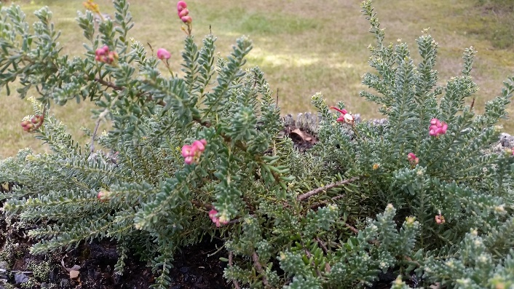
- There have been many skinks around the cabin, enjoying the sunshine, they’re cute!
- The weeping native with little white flowers (to be identified) is flowering beautifully.
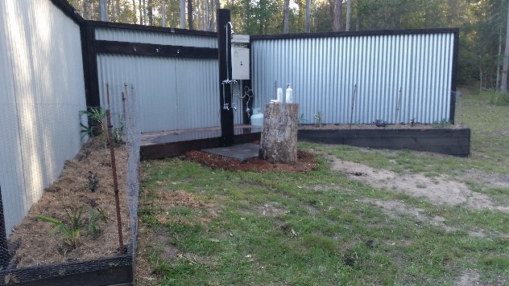
- Seeds have been collected from the Grevillea Venusta and the Grevillea Prostrate. In addition, seeds from the Native Frangipani have also been collected and we will endeavour to propagate these plants for Farmgate.
- The shower bed garden is coming along ok and the frangipanis are flowering beautifully, one pink and one fragrant and white.
- The succulent hanging baskets are doing well, and Shell has replaced some of the other plants as they require more attention, and this is not always possible when holiday letting. We have also discovered the possums love the germaniums and the little succulents in pots.
- Shell has hooked the climbing roses against the pole, she is determined the see them flower next year.
CONSERVATION AREA & NATIVE PROPOGATION
- Wattle Matt Rush seed Propagation late January – Early February near the bridge in the meadow
- Bob was very excited to see the Powerful owl recently. We’ve spotted him a few times now and he is extraordinarily beautiful. White and strong and pure. Bob is endeavouring to get a photo. He has also done some research and discovered they eat possums and is quite happy about that as they are eating his vegetables.

