FEBRUARY IN THE
FOOD FOREST
AT BOOYONG

WHAT’S HAPPENING
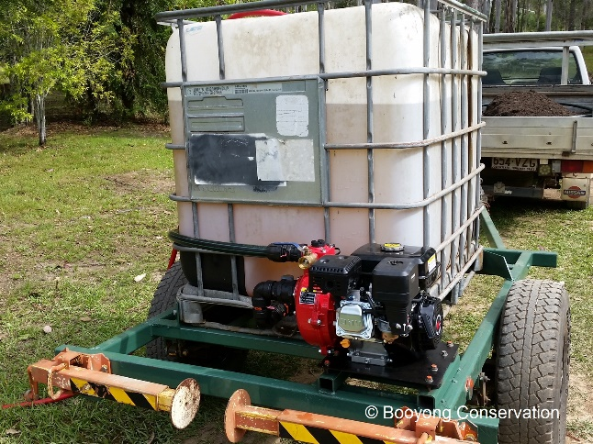
It’s been another dry February at Booyong this year; there have been patches of rain but nothing substantial. The garden pod has been used and Bob has been transferring water from the dam in the front paddock and watering the orchard and gardens regularly. Unlike last summer where we lost several new plantings, they have been sustained which is fantastic!
All the fruit trees are in great shape and becoming well established. Our limes are starting to fruit and should be ready for harvest next month. The persimmons are also close to harvesting and I intend to try some this year and get them before the birds.
The dragon fruit plants are growing well, as are all the citrus trees, peaches and pears.
The pecan’s have not provided any nuts this year due to the dry weather which is disappointing. The Macadamia trees are fruiting well.
The Rosella plantings are doing well by the refurbished food forest dam. One is going so much better that the others – so random! We have 10 planted so should get a good crop this year. The kangaroos don’t seem to want to eat them either which is a bonus.
The Port Macquarie Bird watches group visited the Property for a day which was great.
PREPARATION
- Sow spinach and lettuce for winter
- Collect seeds from Fennel, radishes, coriander, parsley and nigella
SEWING SEEDS
- Sow cabbages, spinach, corn, zucchini and oriental greens
- Sow Amaranth seeds, beans, beetroot, carrot, cucumber and cauliflower
- Sew Kohlrabi, leeks and lettuce seeds, raddish, rosella and spinach seeds
ROUTINE CARE
- Continue to weed and water regularly
- Ensure plants are well mulched to retain moisture
- Water pecan trees (1300 litres per day)
- Pull up any plants that have bolted to seed
- Fertilise Lemon and Lime tree with cow manure
- Citrus is ever-green so balancing and pruning your tree applies all throughout the year.
HARVESTING
- Harvest corn, remaining tomatoes, cucumber, peppers, eggplant and chillies
- Continue picking any beans, carrots, parsnips, celery, beetroot, peas, zucchinis, beans and spinach
- Life remaining onions and shallots or potatoes
OTHER TASKS IN THE GARDEN
Bob has started on the Firewood in preparation for Winter which is promising.
Shell has identified two types of Macadamia trees in the food forest which was interesting, there is always something to learn.
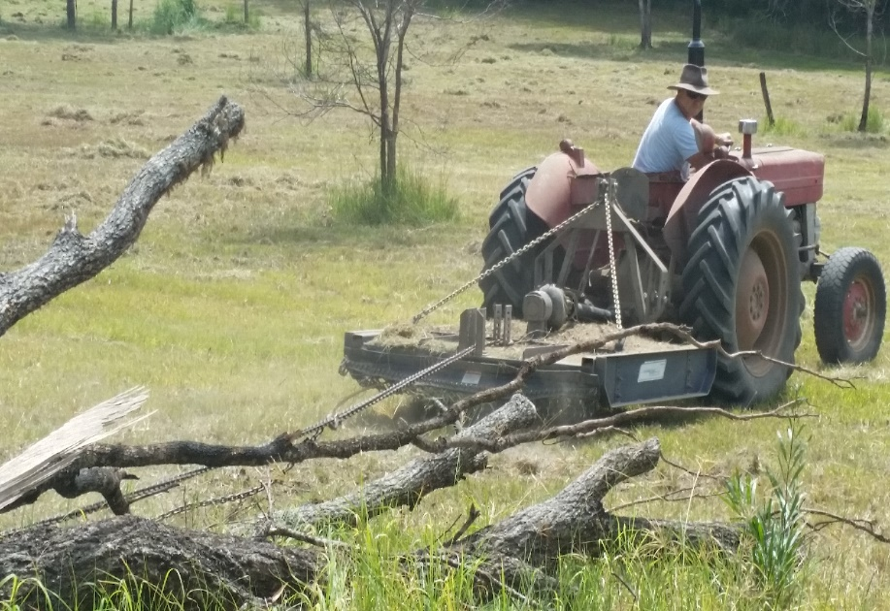
NORMAL FARM AND CABIN MAINTANENCE
We’re patiently waiting for rain so the refurbished dam can fill and we can begin to plant edibles in this area and start looking at irrigation method for the food forest.
The fallen trees have been placed in a pile in the meadow in preparation for a Winter burn off.
Brett and Shell have purchased a couple of sofa beds to be stored in the loft area.

GARDEN BEDS AROUND THE CABIN
Shell is very happy to see the little wrens and finches have returned and we’ve kept the birdbath full during the hot Summer days so they can bath and play.
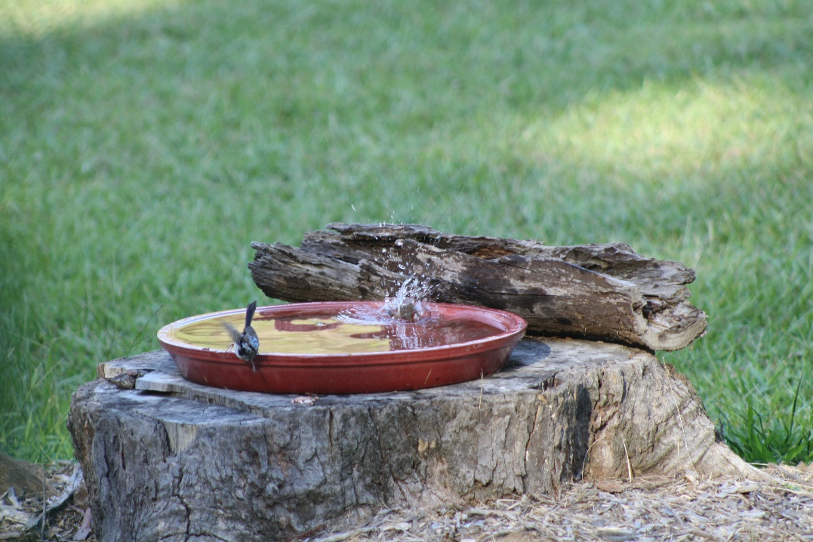
Brett accidently pulled out a grevillea in the front garden bed, mistaking it for a weed!

