MARCH IN THE
FOOD FOREST
AT BOOYONG

WHAT’S HAPPENING
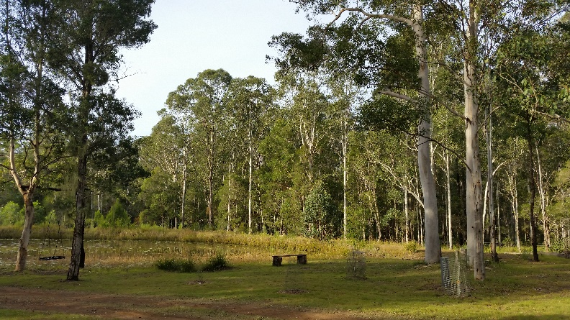
With the recent rains Booyong is becoming green and lush, the mornings are misty, and the weather is cooling into the mornings and afternoons.
Our citrus trees are doing well, and the established trees have abundant fruit. The new blood orange, naval orange, lemonade tree and kaffir lime, lemon and grapefruit are all still doing well.
The Turmeric is also sprouting which is so exciting, I was a little worried about this as we had transplanted it from in front of the cabin.
Unfortunately, we lost one of our Avocado trees in the dry season, so we will need to replace it. In addition, the currant tree was lost.
PREPARATION
- As our poultry increase in numbers, we are looking at creating a veggie garden bed located close by to grow food to feed them.
SEWING SEEDS
- Sow Spinach, beetroot and Oriental salad seeds
- Plant Legumes - Crimson Clover in late March to April for nitrogen under pecan trees and Red Clover March-June or August-October. I’ll plant these when I visit next month as we are only here for a weekend in March.
PLANT
- Plant out cabbage, broccoli, cauliflower and spinach seeds for winter harvest
- Water pecan trees (1300 litres per day)
- The Lemongrass is well established in the garden which is fantastic.

ROUTINE CARE
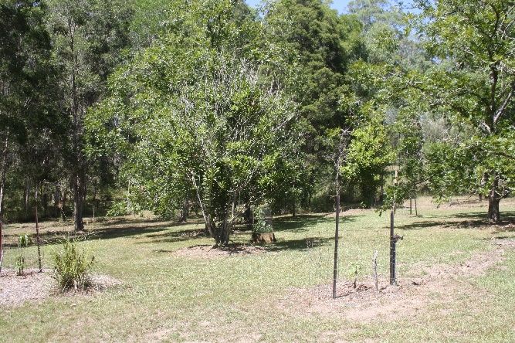
- Remove any dead foliage and clean out veggie beds
- As the crops finish prepare the beds for winter seedlings, add compost and manure and look at improving soil structure where possible.
- Fertilize Seville Oranges
- Fertilise Macadamia nut tree - When fertilising use a native or citrus plant product as they are sensitive to phosphorus
- Fertilise Dragon fruit with light fertiliser (Chicken manure) and lime. Make sure it is mulched well in preparation for summer and take any cuttings from Ariel roots on pole.
- Reduce watering as weather cools and hopefully rainfall increases.
- Cut back perennial herbs and flowers once they have finished flowering.
- Continue weeding where required
- Stone Fruit Salad Trees and Apple Fruit Salad Trees will start to shed their leaves, check to see that trees are balanced and prune where necessary. Cut off any dead wood.
- Remove roots from under graft of fruit trees
- Leaves will start to fall of Persimmon tree after fruiting.
- Fertilise citrus trees, keeping away from the trunk
- Top up mulch on orchard trees
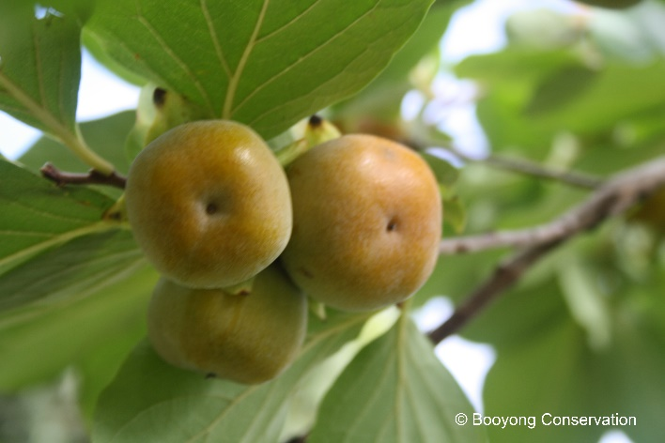
HARVESTING
- Persimmons are ready for harvest
- Harvest Pecan Trees (not this year due to limited rain)
- Harvest beans, zucchini, spinach, summer cabbage, eggplants, chillies and cucumbers etc
- Lift carrots and potatoes and beetroots

OTHER TASKS IN THE GARDEN
Bob’s Firewood shed is well under way and Brett is digging the ground for electrical wires to go the shack and garden shed.
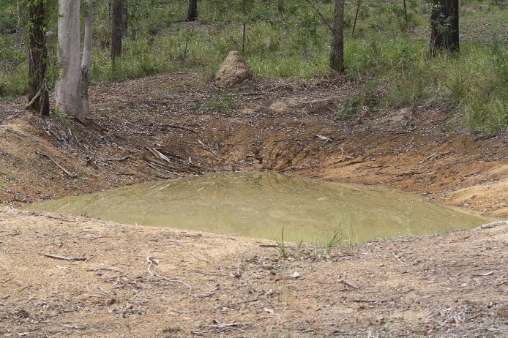
NORMAL FARM AND CABIN MAINTANENCE
The refurbished dam is half full which is fantastic – almost there!
The belts on the mower were replaced and shell has learnt to use the zero-turn mower – so exciting. It’s quite fun.
GARDEN BEDS AROUND THE CABIN
Shell is very happy to see the little wrens and finches have returned and we’ve kept the birdbath full during the hot Summer days so they can bath and play.
Shallots and parsley have been added to the herb garden.
A new grevillea was purchased to replace the two that died.

