APRIL IN THE FOOD FOREST
AT BOOYONG
WHAT’S HAPPENING
Things are beginning to slow down in the garden at Booyong as the weather cools and we are busy cutting firewood and preparing for winter.
The weather has been unusually warm with a little rain. The dam is filling, and the firewood shed is almost finished.
We have had consistent bookings throughout the month which has been fantastic, May is looking very busy with regular bookings, both new and repeat visitors. All proceeds will go towards the property with a new entrance way in planning. Never a dull moment!
Michelle is still researching the fruit trees in the Orchard and expects to have monthly planning and fruit tree maintenance up to date in May. We will then focus on improving the soil and creating under layers of edible herbs and shrubs.
Jack and Michelle removed some Macadamia seedlings from the kiwi fruit farm as they had extended beyond the kiwi fruit farm. We were recommended to do so from a land care representative as they have come from a large tree in the Native Food Forest that could potentially spread throughout the Conservation area. These will be used in crop swaps to obtain new fruit trees for the food forest.
PREPARATION
- Dig in green manure sown in late summer and sow green manure for over wintering.
- Blueberries - Add aluminium sulphate of sulphur which creates acidity in the soil as soon as it dissolves. At Booyong our soil is heavy clay, so we need to add plenty of good quality compost or peat moss. Azalea potting mix is also perfect for them. We add our coffee grounds as they are used (1-part coffee to 10 parts soil), chicken manure and pine needles.
- Grapefruit - Improve heavy soils by incorporating large amounts of compost and a few buckets of gypsum into a planting area at least 2m wide. If your soil is acid, add lime when preparing the soil to bring it up to the preferred pH.
SEWING SEEDS

- Sow pea, cauliflower and cabbage seeds
- Plant Legumes - Crimson Clover in late March to April for nitrogen under pecan trees and Red Clover in March-June
PLANT
- Plant our garlic
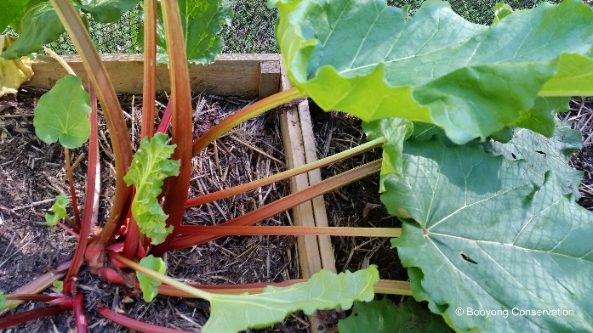
- Divide rhubarb crowns and plant new sets
- Plant seed or seedlings of broccoli, kale and collards, mustard, peas, broad beans, cabbage, cauliflower, parsley, rocket, spinach, silver beet, beetroot, Florence fennel, the onion, shallots, spring onions, leek, garlic; celery, coriander, mizuna, tatsoi. Sow carrots, radish, parsnips, kohlrabi and turnips from seed only. Broad beans can be sown until May.
- Plant potatoes into well-mulched beds in warmer areas; only use certified seed potatoes to avoid introducing damaging virus diseases to your garden.
- Try our colourful Good Bug Mix, a cottage garden mix with 12 types of seed in 1 packet to attract beneficial insects to your garden.
- Microgreens and sprouts to sow now: pea, radish, beetroot, broccoli, alfalfa, wheat, barley, oats, fenugreek, cabbage.
- In frost-free areas of northern NSW beans, capsicum, cape gooseberries, cucumbers, eggplant, melon, pumpkin, okra, zucchini and tomatoes can be planted until the end of April.
- Sow seeds of spring flowers of viola, hollyhocks, stock, dianthus, cornflower, alyssum, poppy, snapdragon and calendula.
- Microgreens and sprouts to sow now: barley, beetroot, broccoli, cabbage, fenugreek, oats, pea, radish and wheat.

ROUTINE CARE

- Clean up any plants that have finished cropping and take down canes and supports. Pull out old beans, zucchini and tomato plants.
- Prune Yellow foliage on asparagus back to the ground and mulch crowns with cow manure
- Apply seaweed to Tropical peach tree
- Citrus is ever-green so balancing and pruning your tree applies all throughout the year.
- After harvest internal branches of the Macadamia nut tree should be removed to open up the trees and allow air circulation.
- Shape Persimmon tree
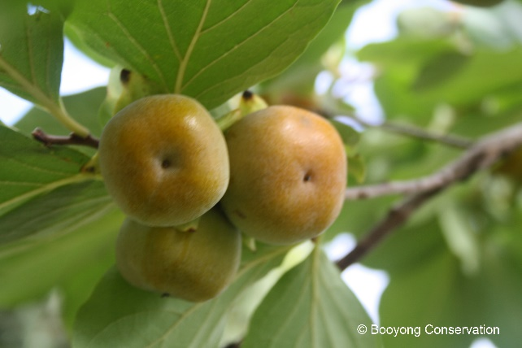
- Blueberries - while fruiting it doesn’t hurt to feed every couple of weeks with seasol or liquid fish.
- Avocado’s and Mangoes – provide protective covering to protect from frost.
- Mangoes - Withhold water for the three months prior to flowering
- Chickens – Scrub water containers daily to prevent algae, check net litter weekly and replace if soiled. Add crushed garlic to drinking water monthly to reduce internal parasite (1 clove per 2-3 hens)
- Figs and Frangipani – Protect from frost
HARVESTING
- Harvest tomatoes, cucumbers, corn, beans, eggplants, peppers, chillies and sweet potatoes
- Continue to pick zucchinis and summer squashes
- Continue picking spinach, leeks and lettuces
- Harvest mature pumpkins and melons
- Harvest Pomegranate - Fruit can be picked prior to maturity and will ripen in storage and can be stored for several months if hung in a cool aired place
- The last of the Persimmons are being harvested
- Harvest Finger limes
- Harvest Macadamia nuts
- Harvest Pumpkins leaving 4-6 cm of stalk at the top and avoid lifting the pumpkins by the stalk.
OTHER TASKS IN THE GARDEN
Michelle is exploring floating pots in the dam and with Brett’s help has planted chocolate mint (from our Sydney garden) and Vietnamese mint in some temporary pots made from water piping.

Lantana is in flower and has been removed from the roadside edges of the property. This will be a never-ending task but one worthy of our time and attention.
Fireweed has been removed around the main dam, once again a regular task to avoid it spreading.
Potash – has been added to the Apples, Peaches and Apricots.
The Outdoor Shower garden bed has been replenished with tropical plants from our Sydney garden.
Nasturtiums have been planted in the chilli garden bed.
NORMAL FARM AND CABIN MAINTANENCE
The refurbished dam is three quarters full which is fantastic – almost there!
Gas bottles for the shower were filled and changed.
Brett and Bob have been busy completing the trenches for the electrical wiring throughout the property and are awaiting an electrician to complete the job.
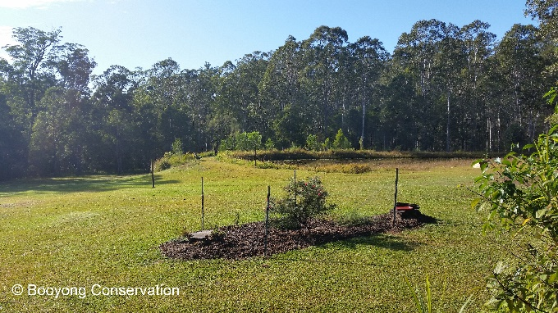
GARDEN BEDS AROUND THE CABIN
Michelle weeded the front garden bed, it is evident that edging is required to eliminate the time required to maintain this garden bed.
The yellow hibiscus is flourishing and flowering beautifully in the cabin garden bed.
Parsley has once again been added to the herb garden.

