MAY IN THE FOOD FOREST
AT BOOYONG

WHAT’S HAPPENING
The rosella’s were ready for harvest but the wallabies and kangaroo’s got there first. It’s been a very dry few months and they are obviously very hungry. The dams are very low and the creeks are also very dry.
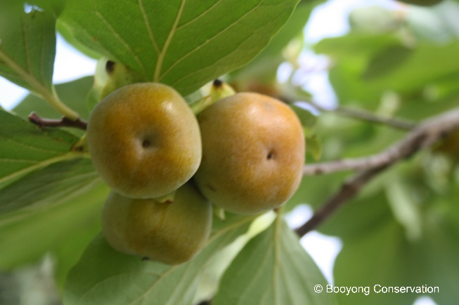
The oranges and grapefruits are growing bigger and starting to ripen which is fantastic. The persimmon tree is beginning to lose its leaves as the weather cools. We had a great crop again this year.
The rhubarb is growing well and the turmeric is starting to die off and will soon be ready to harvest.
The herb garden is coming along nicely, and the lemongrass has settled in well to the garden bed near the palm tree. The rosemary, oregano, basil, parsley and mint or a great addition to the garden and used often for cooking when we visit.
Michelle has finally completed researching the existing fruit trees in the Orchard and the monthly planning and fruit tree maintenance is up to date. She is now working on companion plants and improving the soil.
Floating aquatic pots have been made for the food forest dam and chocolate mint, brahmi, rainbow celery, vietnamese mint and watercress have been planted. Michelle is researching and exploring other aquatic edible pond plants that may be appropriate.
Brett and Michelle are continuing to plant natives around the shed, we’re very excited to see them flourishing. The firewood shed is almost complete and we intend it to be lovely and full in preparation for next winter. Michelle is planning to make a succulent garden around it, which will be allot of fun!
The bunnies and chickens are not at Booyong at presents, they are with friends while improvements are being made to their enclosure and we look forward to them returning home in Spring.
PREPARATION
- Start digging well-rotted compost or manure into vegetable beds.
SEWING SEEDS
- Sow beans (broad beans, fava beans) and peas (snow and sugar)
- Sow garden chives
- Sow cauliflower and carrot seeds
- Sow lettuce and mustard greens
- Sow parsley and radish seeds
- Sow shallots, spinach and leeks
- Plant out strawberry plants
- Plant Legumes - Red Clover March-June for nitrogen under pecan trees
PLANT
- Divide rhubarb and plant out garlic
ROUTINE CARE
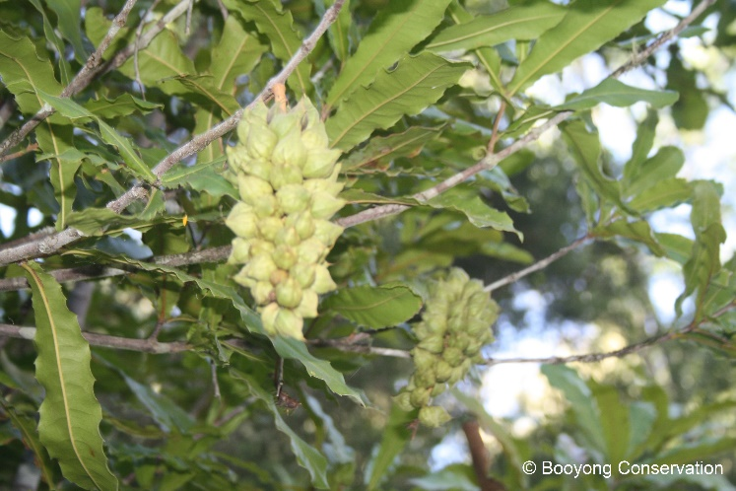
- Continue to clear away plants that have finished cropping
- Fertilise macadamia nut tree - When fertilising use a native or citrus plant product as they are sensitive to phosphorus
- Add coffee grounds to blueberries
- Mangos - withhold water for the three months prior to flowering
- Chickens – Scrub water containers daily to prevent algae. Check net litter weekly and replace if soiled. Add crushed garlic to drinking water monthly to reduce internal parasite (1 clove per 2-3 hens)
- Prune Finger limes lightly
- The lemon and lime tree has some black spot and is being treated with oil
HARVESTING
- Pick winter cabbages, cauliflowers, brussel sprouts, kale or leeks
- Continue picking spinach and beans
- Limes are ready for harvest
- Anne’s bell peppers are turning a lovely red and are also ready to harvest
- Harvest pomegranate - fruit can be picked prior to maturity and will ripen in storage and can be stored for several months if hung in a cool aired place
- Harvest finger limes
- Harvest oranges
- Macadamia nuts are continuing to be harvested

PROPOGATION
- Collect seeds from Anne’s Red Bell Peppers
OTHER TASKS
- Start collecting potash from fire for garden in Spring
NATIVE GARDEN & GARDEN BEDS AROUND THE CABIN
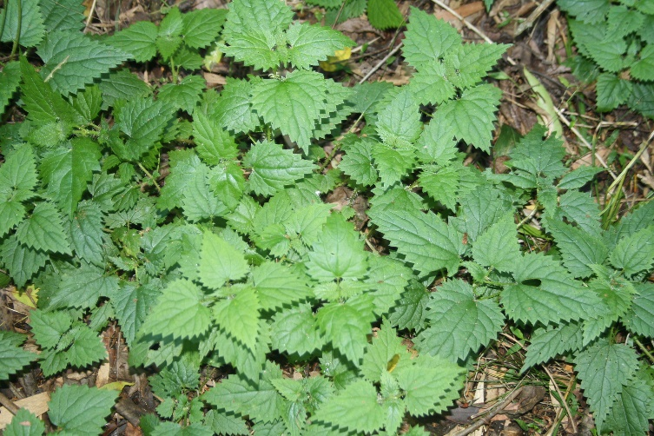
- Prune Grevillea Moonlight lightly
- The other variety of Native Grape are fruiting in the native food forest
- Stinging nettle is being harvested and dried in the food dehydrator to make tea and powder
NORMAL FARM AND CABIN MAINTANENCE
- The front paddocks have been slashed in preparation for Winter
- A Mulcher has been purchased and Brett is in the process of doing farm equipment maintenance
- Firewood has been purchased for upcoming bookings
- Some of the electrical trenches have been filled in and we are awaiting the electrician to hook up the outdoor power points

