JUNE IN THE FOOD FOREST
AT BOOYONG

WHAT’S HAPPENING
It’s been a very dry and dusty June at Booyong, with very little mowing required.
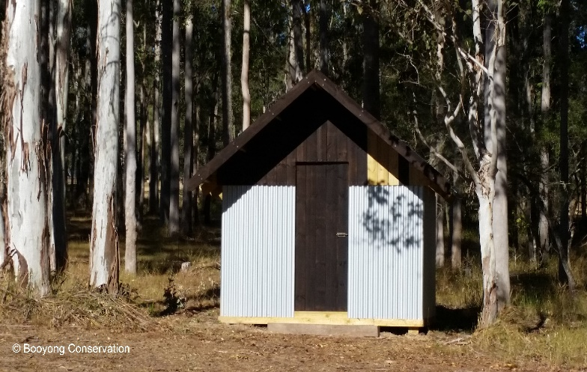
The firewood shed is now complete and will be stocked up for next year. Michelle is creating a succulent garden bed around it which will be great.
The electrical wiring has been connected to the outdoor garden beds, shower and the gardening shed. This involved the digging of trenches and laying of wires and pipes throughout the property. An enormous task and we are so grateful to friends who helped us.
We now have a chipper and Brett has been busy modifying Betsy for external hydraulic devices, so looking forward to giving it a go soon and making our own mulch.
Michelle has been bust adding cow manure and mulch to the fruit trees in the food forest and salvia’s, comfrey and borage plants have been added to attract bees and beneficial insects.
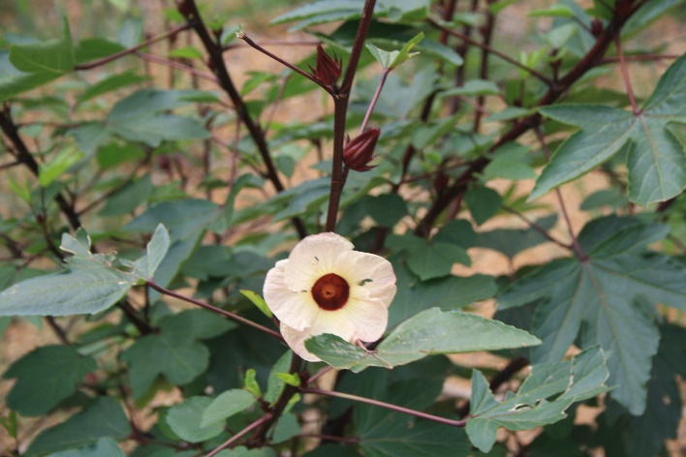
The citrus trees (grapefruit, orange and Seville orange) have been abundant again this year and we will once again make grapefruit marmalade which is becoming a regular Winter occurrence.
The local wildlife has been looking for fresh and new growth and have annihilated the Rosella plants which were abundant with fruit. This was so very disappointing. We will be sure to protect them next year.
PREPARATION
- Spread well-rotted manure or compost over vegetable garden beds
- Buy seed potatoes
- Order some seeds and go through seed inventory
SEWING SEEDS
- Beans broad and fava to Harvest from September
- Sew Cabbage seeds to Harvest from July
- Plant Garlic cloves to Harvest from October
- Kale to Harvest from July
- Continue to plant lettuce seeds and mustard greens
- Plant radish and pea seeds
- Plant out strawberry seedlings to harvest from September
- Plant beetroot seeds and spinach
- Plant Legumes - Red Clover March-June for nitrogen under pecan trees
PLANT
- Plant onion and shallot sets if ground isn’t too wet
ROUTINE CARE
- The Rhubarb at our home in Sydney has successfully been separated, Booyong’s plants are just newly established so will be separated (2019 and then every three to four years) and the patch will be extended.
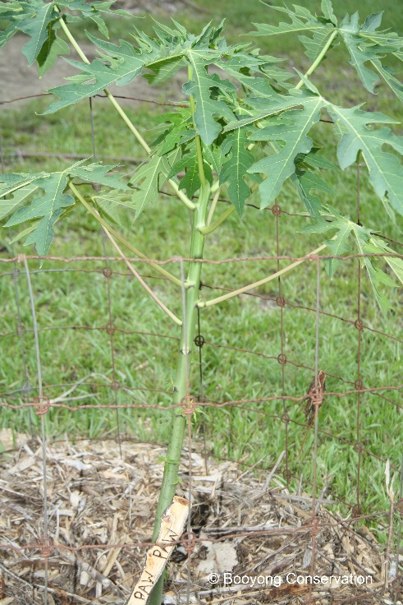
- The herb and chilli garden bed has been mulched and nasturtiums added.
- Weed fireweed from the long grass in dam walls
- Add Blood and bone to strawberries
- Continue to collect potash from the fire for the food forest gardens
- Avoid leaf curl by spraying your Tropical Peach tree with lime sulphur spray several times over winter prior to buds bursting.
- Net Paw Paw tree to protect from frost – it also doesn’t like allot of water in Winter
- Fertlise Dragon fruit with light fertiliser (Chicken manure) and lime. Make sure it is mulched well in preparation for summer and take any cuttings from Ariel roots on pole.
- Add coffee grounds to Blueberries
- Prune the Apricot tree and fertilize with well-balanced fertiliser.
- Prune the Pomegranate lightly and remove ant limbs causing crowding in the centre.
- Prune the Mulberry tree lightly feeding leaves to chickens and using them as fodder, feed with blood and bone afterwards.
- Chickens – Scrub water containers daily to prevent algae. Check net litter weekly and replace if soiled. Add crushed garlic to drinking water monthly to reduce internal parasite (1 clove per 2-3 hens)
- Prune Goji Berry
- Fertilize the Mandarin in Spring and Winter with cow or chicken manure and Seasol.
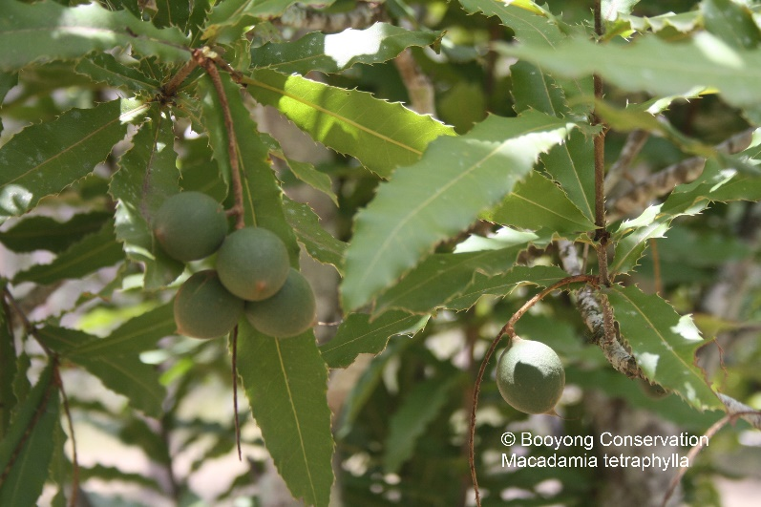
HARVESTING
- Harvest Lemons
- Grapefruits harvested
- Seville Oranges harvested
- If you have them, pick winter Cabbages, Cauliflowers, Brussel sprouts, Kale and Leeks
- Dig up Turmeric
- Continue to harvest remaining Macadamias
PROPOGATION
- Collect seeds from Anne’s Red Bell Peppers
- Seeds have been collected from the Rosella plants for next year
NORMAL FARM AND CABIN MAINTANENCE
- The Shed gutters have been cleaned out to ensure water stays clean.

