AUGUST IN THE FOOD FOREST AT BOOYONG

WHAT’S HAPPENING
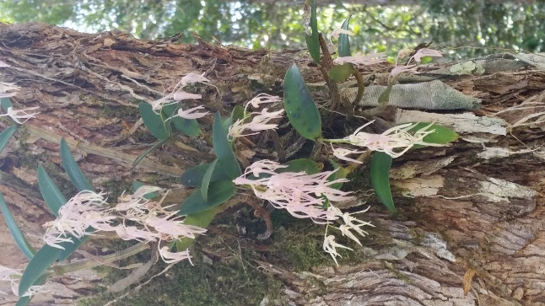
We’re in drought in NSW currently and this is reflected in the dryness of the property. Fortunately, the water tanks are reasonably full for the moment and the plants in the garden and orchard are all doing well. The property is still brown and desperately in need of rain. Despite the dryness, the property is still beautiful. We’re looking forward to the Orchids flowering in September, the birds and stunning nights sky!
Whilst July was all about the fruit trees, August has been about updating the trees species list. Information and species lists have been updated by the Botanical Bush bashers, Landcare and contributions from Van and our previous owners at Booyong - Dave and Beryl. 120 Trees have been listed at Booyong and we’ve identified 21 of them so far – a long way to go.
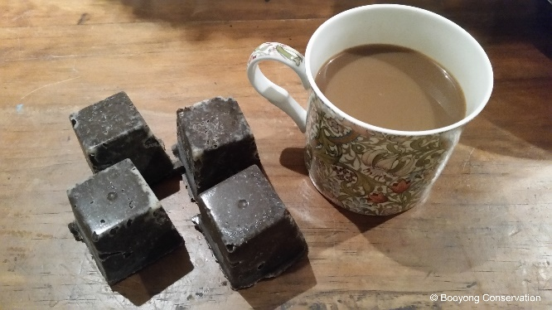
On the recycling front, Michelle has been exploring interesting ways to use coffee grounds. Herbs have been dried and native ground covers have been planted around the shed.
In addition, a succulent garden has been planted around the garden shed – just for fun!
PREPARATION
- Spread well-rotted manure or compost over vegetable garden beds.
- Order required seeds and go through inventory in preparation for Spring.
SEWING SEEDS
- Sow onion seeds
- Plant Legumes - Red Clover August - October for nitrogen under pecan trees
- Plant Artichokes (Globe), Asparagus, Beetroot, Cape Gooseberry, Capsicum, Bell Peppers, Chilli’s, Eggplant, Kohlrabi, Leeks, Lettuce, Mint, Mustard Greens, Peas, Parsnip, Potato, Radish, Rocket, Strawberries, Thyme, Tomato
- Seeds from the Mexican Coriander were collected
PLANT
- Plant onion and shallot sets if ground isn’t too wet
- Red chilli seeds planted in Chilli garden bed in food forest
ROUTINE CARE
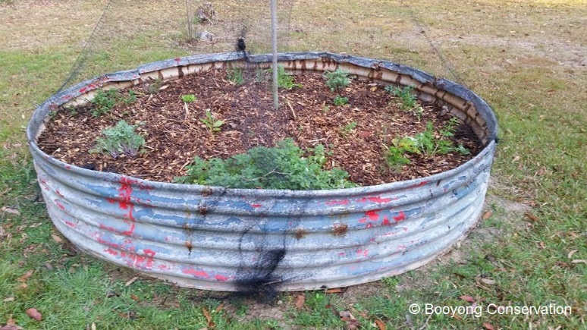
- Top dressed herbs and herb garden mulched and weeded. The oregano, mint and basil has been placed in pots within the herb garden.
- Fireweed has been removed to prevent it from going to seed and spreading
- Wisteria has been cut back and tied with string
- The Tropical Peach tree has been sprayed with lime sulphur spray several times over winter prior to buds bursting to prevent leaf curl.
- Citrus is ever-green so balancing and pruning your tree applies all throughout the year. We have cut off any dead wood on all our citrus trees.
- Macadamia nut trees have been pruned and internal branches have been removed to open the trees and allow air circulation.
- Coffee grounds continue to be added to Blueberries and while fruiting it doesn’t hurt to feed every couple of weeks with seasol or liquid fish.
- Avocado – add a mulch of sugar cane straw and compost up to 10cm thick. Unfortunately, we lost one Avocado tree due to frost.
- Chickens – Scrub water containers daily to prevent algae, check t litter weekly and replace if soiled. Add crushed garlic to drinking water monthly to reduce internal parasite (1 clove per 2-3 hens). Our chook pen is currently being cleaned and prepared for Spring and our chickens have been gifted to our neighbours. During this time, we are enjoying eggs from our neighbour Rosemary and Fred’s farm.
- The Pineapple Guava (Fejoia) tree has been fertilised with Nitrogen rich fertiliser
- Prune Olive Tree – ours is not currently in need of pruning.

HARVESTING
- Lemons – harvested
- Pick winter Cabbages, Cauliflowers, Brussel sprouts, Kale and Leeks
- Seville oranges and grapefruits harvested, and Marmalade made and shared with friends
- Calendula flowers ready to harvest and infused in oil
- Lavender flowers harvested and dried
- Thyme dried
- Rosemary dried and made into salt
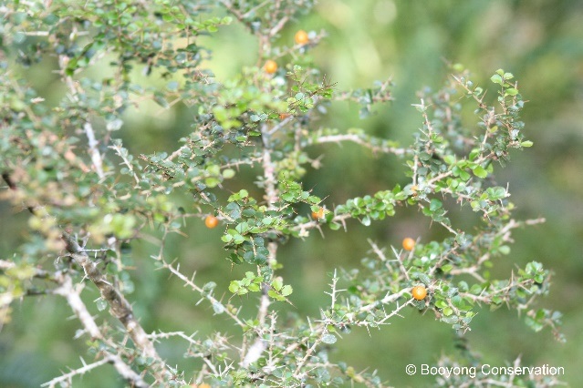
NATIVE FOOD FOREST - HARVESTING
- Stinging Nestle harvested - pesto made
- Orange Thorn fruiting
NATIVE SEED PROPOGATION
- N/A
FARM MAINTANENCE
- Brett cleaned out shed gutters to keep water clean and a strong flow should we get rain
NATIVE GARDEN
A variety of native ground covers have been planted around the shed.

