JULY IN THE FOOD FOREST AT BOOYONG

WHAT’S HAPPENING
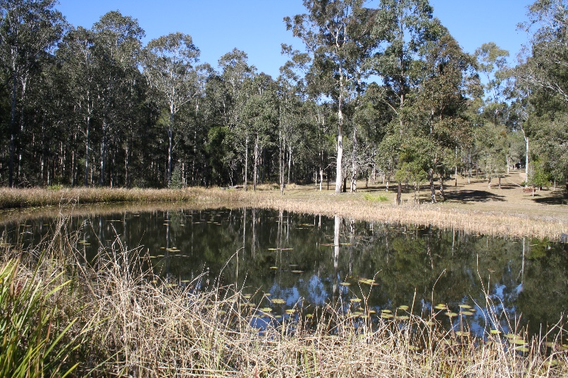
It’s been a very dry winter at Booyong and the trees are looking distressed. Fortunately, all of our plants are doing ok and we are continuing to water them each time we visit. During times like these, you can only hope your plants stay alive and prepare for when the rain comes.
It’s dry and the dams are low! We’re having lots of discussions regarding water and how to preserve it in the future.
PREPARATION
- Spread well-rotted manure or compost over vegetable garden beds
- Buy seed potatoes
- Order some seeds and go through seed inventory, this has been fun. I’ve also enjoyed sharing seeds with my lovely friends Mette and Francey and members of Sydney Crop swap.
SEWING SEEDS
- Sow onion seeds
- Sow beetroot seeds, broad beans, cabbage, cornflower, camomile, lettuce, marigold, mizuna, parsnip, radish, peas and spinach.
PLANT
- Plant onion and shallot sets if ground isn’t too wet
- We’ve planted Kale, Spinach and celery in Bunny garden bed in preparation for when they return to the farm. The bed has been tided up and mulched.
- Garlic has been added to the herb garden
- Oregano, comphrey, basil and borage have been companion planted in the food forest amongst the fruit trees
- Salvia’s gifted from Cecilia at Crop swap have also been planted throughout to attract bees and beneficial insects.
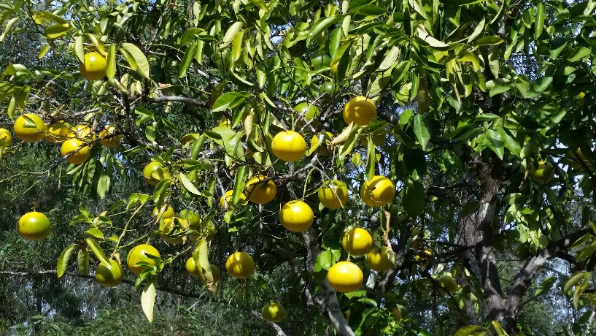
ROUTINE CARE
- Force Rhubarb if new shoots are beginning to sprout
- Potash from the fire has been added to the terrace garden bed in preparation for spring planting.
- Fertilise lemon and lime tree with cow manure
- Native plants fertilized
- Fertilise Seville Oranges with chicken manure
- Avoid leaf curl by spraying your Tropical Peach tree with lime sulphur spray several times over winter prior to buds bursting.
- Fertilizer Persimmon in late winter with manure and blood and bone.
- Add coffee grounds to Blueberries
- Blueberries - while fruiting it doesn’t hurt to feed every couple of weeks with seasol or liquid fish.
- Grapefruit - apply a well-balanced organic citrus food.
- Chickens – Scrub water containers daily to prevent algae. Check net litter weekly and replace if soiled. Add crushed garlic to drinking water monthly to reduce internal parasite (1 clove per 2-3 hens)
- Dead branches from the Orange and Grapefruit trees have been pruned.
- Macadamia trees have been thinned out after harvesting
- Oregano, Mint and Basil have been transplanted into pots within the herb garden as they were taking over.

HARVESTING
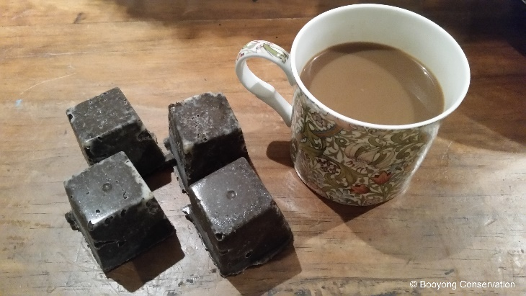
- Lemons – ready to harvest
- Pick winter Cabbages, Cauliflowers, Brussel sprouts, Kale and Leeks
- Grapefruits and Seville oranges have been harvested and turned into delicious marmalade.
- Turmeric was harvested and replanted in the Food forest
- Oregano and Stinging nettle have been dried in the dehydrator.
- Not really harvesting, but I was very excited to discover uses for our used coffee grounds – a wonderful body scrub was made and is fantastic after a busy day in the garden.
NATIVE SEED PROPOGATION
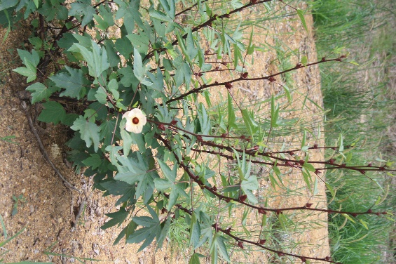
- Rosella seeds collected for next year – this was difficult this year and we will need to source them from elsewhere as the wallabies and kangaroos annihilated our plants.
FARM MAINTANENCE
- The Garden shed has been cleaned out and looks fantastic, all of our pots are sorted and ready for planting.
- Shed Gutters cleaned
NATIVE and CABIN GARDEN
- Poppy, Jack, Brett and shell have mulched the shed garden bed and 50 native ground covers have been planted.
- Succulents were propagated from our Sydney garden and planted around the new Firewood Shed
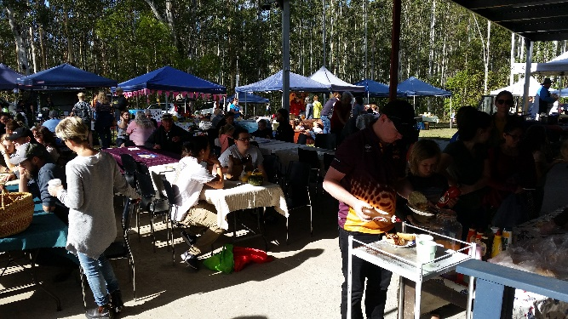
COMMUNITY
- The Botanic Bush Bashers visited Booyong and assisted us to identify lots of trees in the Conservation area, we are looking forward to them returning late September
- We visited Pappinbarra Community market and supported local producers and stall owners, purchasing Chutney and beautiful fruit and nut Sourdough bread.

