SEPTEMBER IN THE FOOD FOREST
AT BOOYONG

WHAT’S HAPPENING
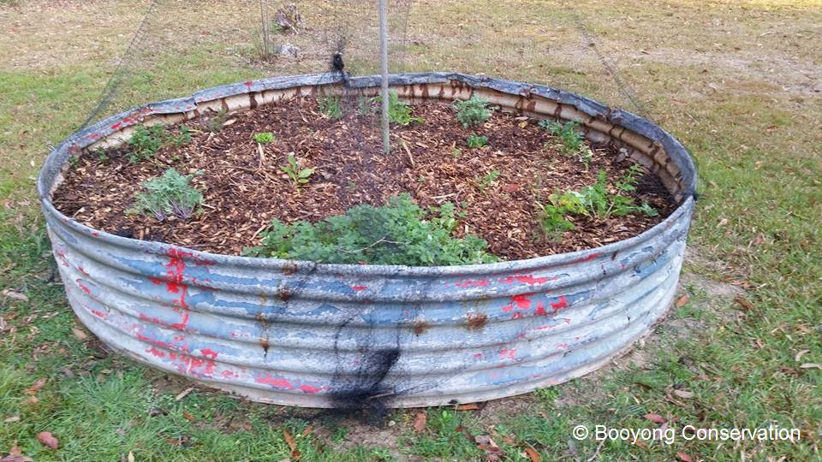
It’s been a long dry Winter at Booyong and this is reflected in the Spring growth. We have lost our Coffee plant, Goji Berry and Avocado during the Winter and have replaced these trees with an Elderberry plant, curry plant and a variety of Salvia’s which are hardy and will attract the bees and beneficial insects.
The Herb garden has been going considerably well and includes parsley, oregano, thyme and chives, rosemary and sage. Edible flowers are also going well and lovely additions to desserts and spring salads. Mint is going well in the pot within the herb garden too.
The floating water edibles are going well in the dam which is promising and we will explore adding more variety soon.
PREPARATION
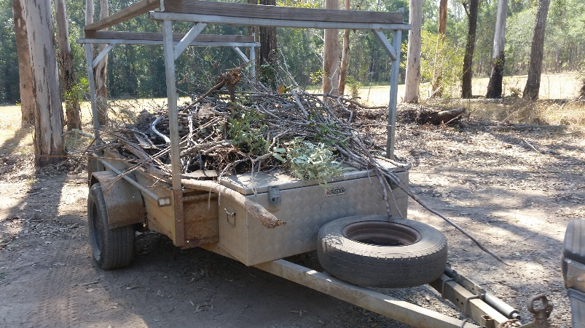
Our current main project is preparing a spiral garden in between the food forest dam and orchard. Brett and I have shovelled tonnes of manure and mulch and will continue to prepare the soil and hold off planting until the drought ends. Our next step is too look at how we will irrigate this area.
The leaves and twigs from the September winds have been raked up and used as mulch in the garden beds around the cabin.
In addition, the sticks have been put through the mulcher to create a bed of mulch in the terraced garden at the base of the food forest dam. I am growing pumpkins and melons from seed, and these will be planted in this area in October.
SEWING SEEDS
- Go through all seeds and organise for planting and storage.
- Sew in pots or directly in ground depending on species and protect from frost or winds if necessary. We’ve made a variety of toilet paper roll seedling pots.
- At Booyong this year we are planting some carrots and spinach for the bunnies. They also love Nasturtiums, so we’ll pop these in too!
- In Sydney, we’ve planted a variety of seedlings we intend to bring to Booyong - Amaranth, globe artichokes, asparagus, , climbing and bush beans, beetroot, broccoli, cape gooseberry, capsicum, cabbage, carrot, celery, chicory, cucumber, kohlrabi, leeks, mustard greens, peas, parsnip, potato, sunflower, pumpkin, radish, rockmelon, watermelon, sage, tomatoes, zucchini,
- Sow herb seeds of chives, coriander, basil, fennel, mint, oregano.
PLANT
- Plant Legumes - Red Clover August - October for nitrogen under pecan trees
ROUTINE CARE
- Fertilize Persimmon tree with chook manure and blood and bone
- Fertilize Blood Orange with citrus fertiliser.
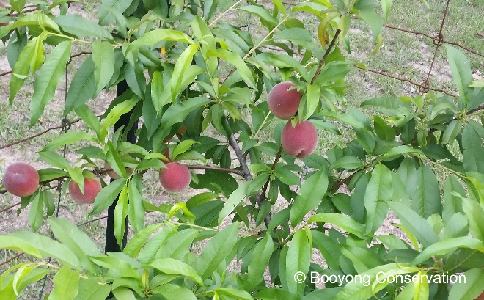
- Tropical Peach - net it and attach some fruit fly bates and apply seaweed solution.
- Pear – Pear Trees can be fed with a sprinkling of blood and bone meal around the outer edge of their drip line (widest edge of outer branches). Plant borage, comfrey, dill and fennel beneath your trees to draw nutrients from deep in the soil and to attract beneficial pollinating and predatory insects. We did plant these at Booyong recently and they have been eaten by animals – it’s a dry season and they are hungry.
- Fertilise Apple tree
- Fertilise Finger limes – 1/3 of citrus fertiliser
- Fertilize Coffee plant with high potassium fertilizer, they also like potash. Sadly, we lost our coffee plant over Winter and will replace it next Spring after the drought has broken.
- Fertilise Jaboticaba with a good helping of slow release fertilizer like Osmocote and regularly during the warmer months with a liquid fertilizer.
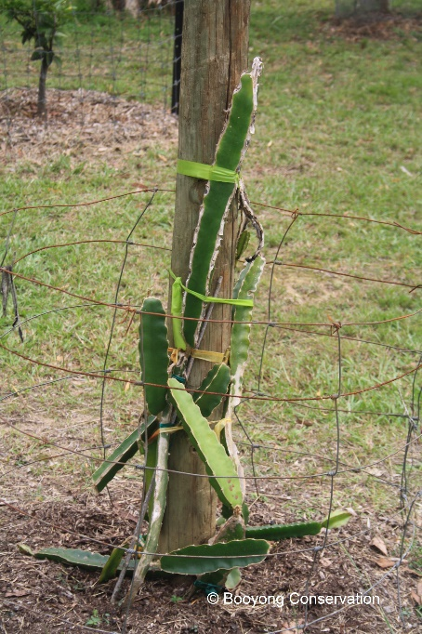
- Fertilize Olives - Fertiliser in early spring and late summer with a well-balanced fertiliser, such as Yates Dynamic Lifter Advanced For Fruit & Citrus or Osmocote Plus Organics Fruit & Citrus, which feeds the plant and enriches the soil, too.
- Fertlise Paw Paw tree with Sea weed every 6-8 weeks before flowering, they also like potash and a sprinkle of gypsum. Don’t overwater to avoid root rot.
- Fertilise Macadamia nut tree - When fertilising use a native or citrus plant product as they are sensitive to phosphorus
- Fertlise Dragonfruit with light fertiliser (Chicken manure) and lime. Make sure it is mulched well in preparation for summer and take any cuttings from ariel roots on pole.
- Fertilise Apricots with a well-balanced organic fertiliser
- Figs – fertilise if new growth is appearing.
- Fertilize Lemon and Lemonade tree with Cow poo, Blood and bone and Citrus fertilizer.
- Water pecan trees (1300 litres per day) and fertilise with Zinc and nitrogen.
- Blueberries - Add coffee grounds to Blueberries and while fruiting it doesn’t hurt to feed every couple of weeks with seasol or liquid fish. Apply a 10cm thick layer of mulch over the soil around the new bush.
- Avocado’s - Searles Kickalong Fruit & Flower organic plant in spring, with a bit of extra potash and add a dusting of a hundred grams per square metre equivalent of gypsum. Unfortunately, we lost our avocado in the frost this year – we intend to replace it next Spring after the drought has broken.
- Mangoes - Mulching is required and keep mango trees well-watered and feed with Fish Emulsion and Seaweed
- Keep up the water with the Pomegranate and remove suckers from the base of the tree. Fertilise with annual manure or compost.
- Rhubarb - regular feeds of cow and chicken manure in spring. It can also be fertilized with blood and bone and a sprinkling of potash.
- Grapefruit - iron sulphate. I put one tablespoon in 4 and half litres of water and apply.
- Kaffir Lime - Fertilize once in early spring
- Fertilize the Mandarin in Spring and Winter with cow or chicken manure and Seasol and lightly prune Mandarin after harvest
- Pineapple Guava - Gardeners must water deeply on a regular basis with special caution during flowering and fruiting periods.
- Remove Rootstock growth which is any new shoots emerging from the main central stem of the tree or coming up from ground level and it all must be removed. Rootstock growth doesn't produce a worthwhile fruit so all growth needs to be going into your grafts.
HARVESTING
- Peach Tree – The fruit tree is starting to bear fruit and we will leave just a couple of fruits on each branch and choose those closest to the thicker part of the branch, not at the very end of the branch. This will continue to be done until the tree is strong enough to support more fruit. Every year we will allow an increase in fruit production.
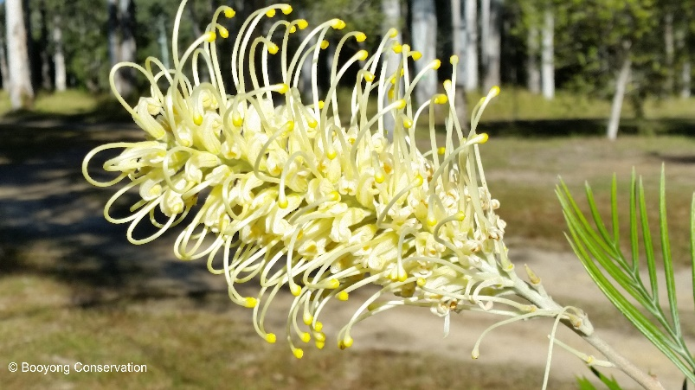
NATIVE GARDEN
- Fertilize Grevillea Moonlight with Native fertilizer
- Grevilleas - At the end of September cut off all the flowers and put them in a vase, then cut the plant back to waist or chest height. You’ll see new growth within a fortnight and the plant will soon be flowering again. Plants that have been left to grow unpruned and have become lank and straggly can be given a rejuvenation prune in spring, right back into hard wood at chest height. The only rule is to avoid pruning when the weather is wet or very hot.
- Garden beds mulched and cabin garden bed weeded.
- Frangapani plants – wire placed around them to protect new growth from roos.
- Mondo grass planted around outdoor shower.
NATIVE FOOD HARVESTING
NATIVE SEED PROPOGATION – N/A
CARING FOR FARM ANIMALS
- Chickens – Scrub water containers daily to prevent algae. Check litter weekly and replace if soiled. Add crushed garlic to drinking water monthly to reduce internal parasite (1 clove per 2-3 hens)
FARM MAINTANENCE
- Leaves raked up after September winds and placed as mulch around trees and cabin garden beds.
- Trailer loads of sticks collected and placed through mulcher
- Spiral garden bed mulching completed and pathways raked
- Entranceway and Bob’s shack cleaned up, leaves and sticks removed
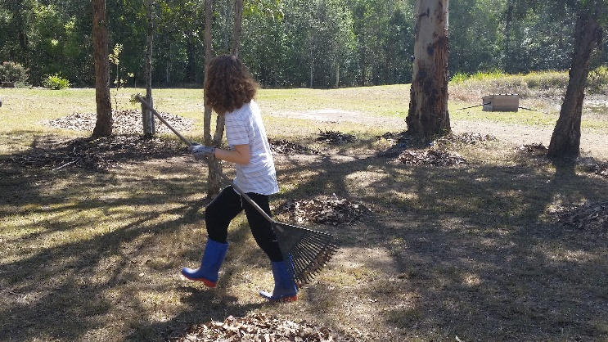
- Tracks cleared after September winds
- Chainsaw blades sharpened
- Lawn mower maintenance completed

